**Name :** Aggelos Konioris

**Batch code :** LISUM02

**Submission date :** 18/8/2021

**Submitted to :** Data Glacier

Short summary of our analysis

* Utilizing the same dataset and the same machine learning model from the last deliverable
* Creating a new environment in the Anaconda Prompt in order to keep only the libraries are utilized in the requirements txt file
* Creating a Procfile in order to declare to the Heroku Cloud Platform which commands it is going to run
* Creating a requirements txt file by typing ‘pip freeze > requirements.txt’ in the Anaconda Prompt
* Naming our application in the Heroku Cloud Platform
* Connecting to the GitHub and deploying our model in the Heroku Cloud Platform
* The application is done

Creating the environment salaryprediction

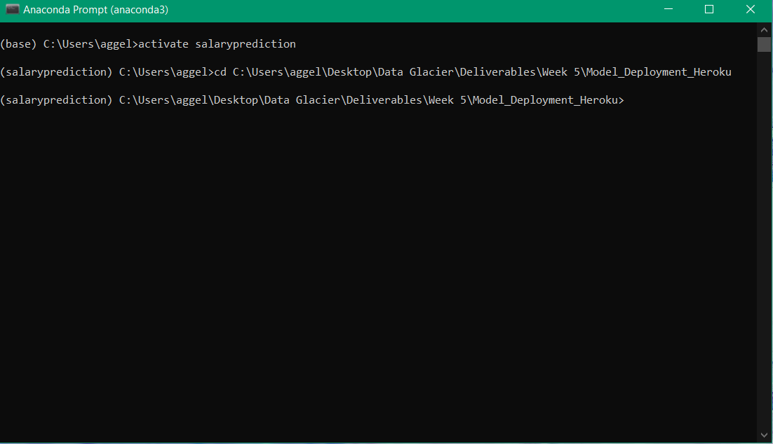

Creating the Procfile

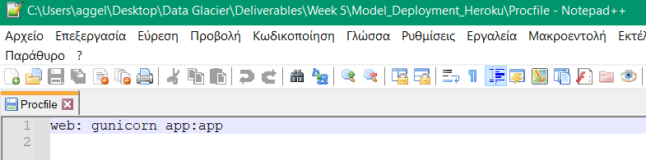

Creating the requirements.txt file

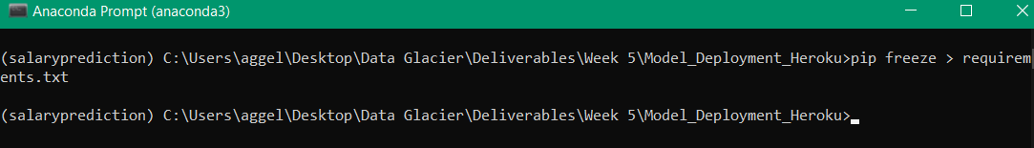

Naming our application as nbasalarypredictions in the Heroku Cloud Platform

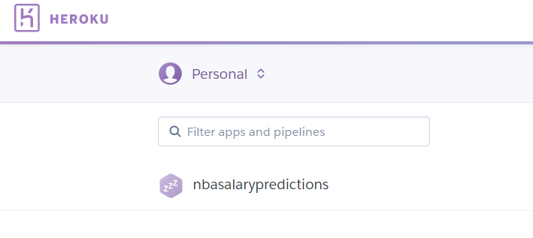

Connecting our application with the GitHub and deploying our model in the Heroku Platform

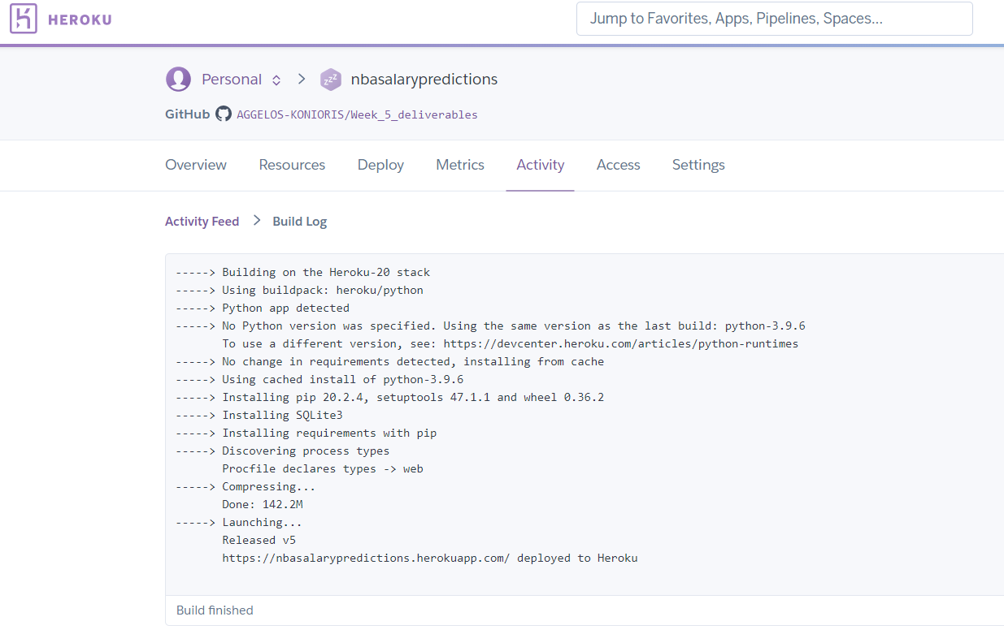

Finally, the application is done

